WEEK 2: Development Environment Setup and Initial Coding

I. INTENDED LEARNING OUTCOME
At the end of this activity, students should be able to:
Develop a functional development environment by configuring required software tools, establishing database structures, implementing foundational system modules, and applying coding standards for collaborative software development.

II. PERFORMANCE TASK
Your capstone project has completed the planning phase. As a development team, you must prepare the software development environment, establish database structures, create the repository framework, implement foundational modules, and adopt coding standards to ensure efficient collaboration and future system expansion.

III. WEEK 2 ACTIVITIES
Activity 1 – Development Environment Configuration
Activity 2 – Database Setup and Implementation
Activity 3 – Framework and Project Structure Setup
Activity 4 – Foundational Module Development
Activity 5 – Coding Standards Establishment
Activity 6 – Repository Initialization and Version Control
Activity 7 – Adviser Validation

ACTIVITY 1
DEVELOPMENT ENVIRONMENT CONFIGURATION

Purpose
To ensure that all required development tools and software components are properly installed and configured.
Procedure
- Install all development tools identified in the Development Plan.
- Verify software versions.
- Configure project workspace.
- Test development environment functionality.
- Complete Form 1.

FORM 1
DEVELOPMENT ENVIRONMENT CHECKLIST

Directions
Check all software successfully installed and configured.
Tool/Software | Required | Installed | Version
IDE | ☑ | ☑ | 1.131.0
Programming Language Runtime | ☑ | ☑ | Python 3.11
Database Server | ☑ | ☑ | SQLite 3 (embedded, WAL journal mode)
Version Control Tool | ☑ | ☑ | Git (CLI) with GitHub remote hosting
Framework | ☑ | ☑ | Flask 3.x with Flask-SocketIO (real-time)
API Testing Tool | ☑ | ☑ | Browser DevTools / Postman

Environment Test Results
Component Tested | Result
IDE Launch | Pass
Database Connection | Pass
Repository Access | Pass
Framework Execution | Pass

Required Evidence
□ Screenshot of Installed Tools
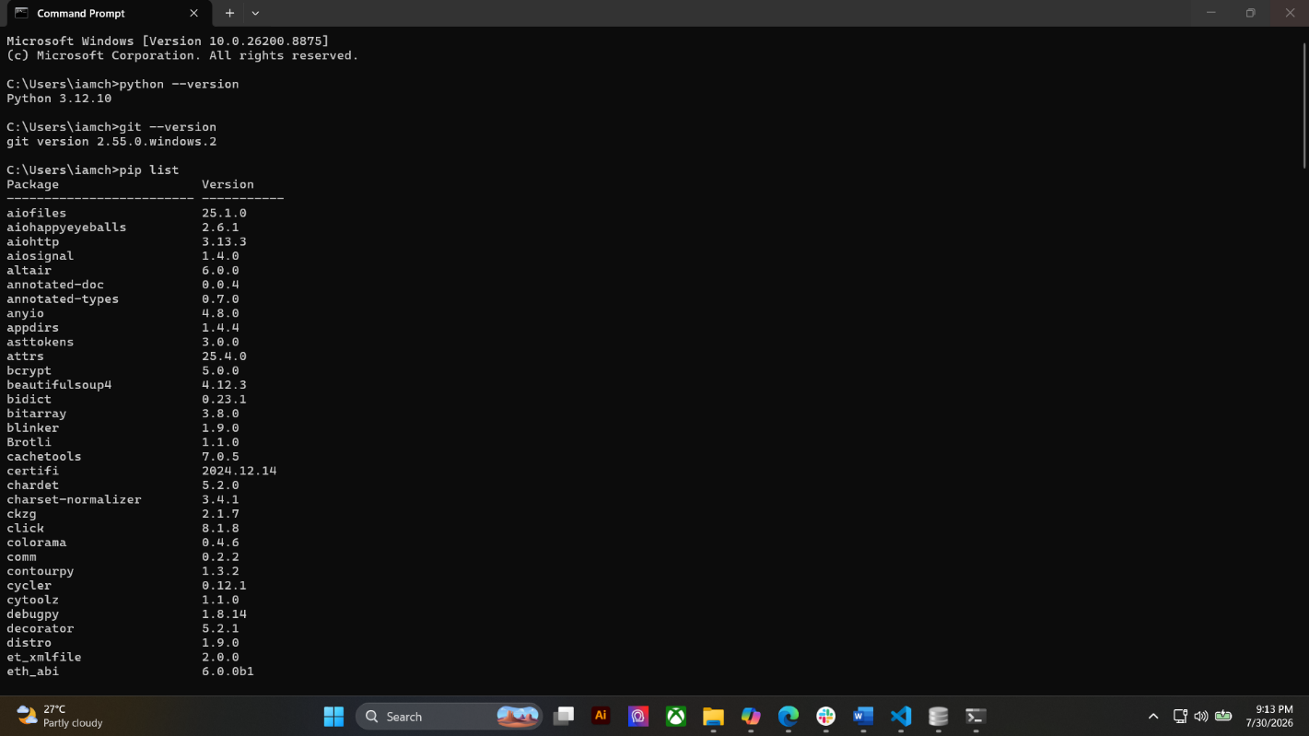

□ Screenshot of Running Development Environment
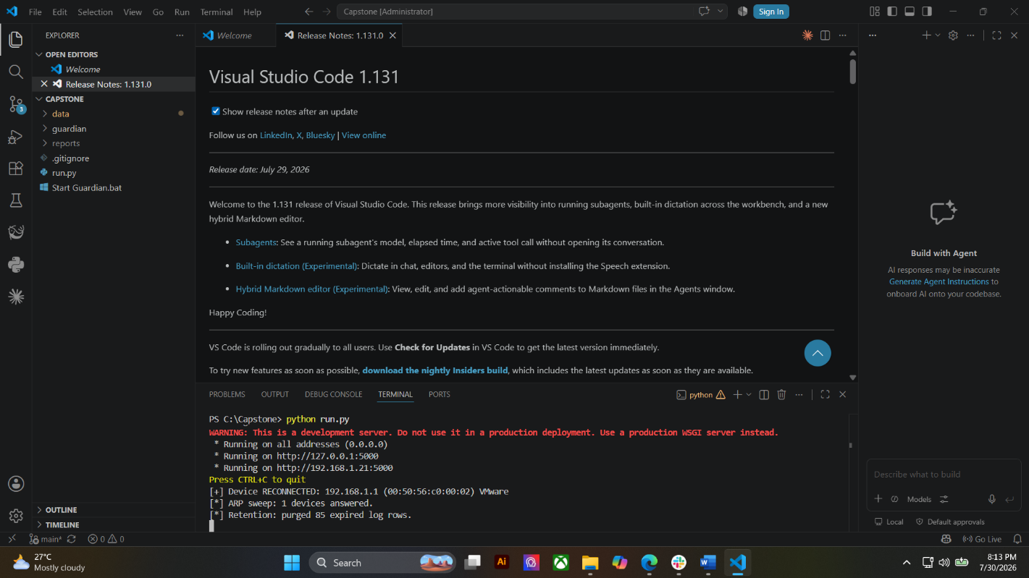

□ Screenshot of Project Workspace
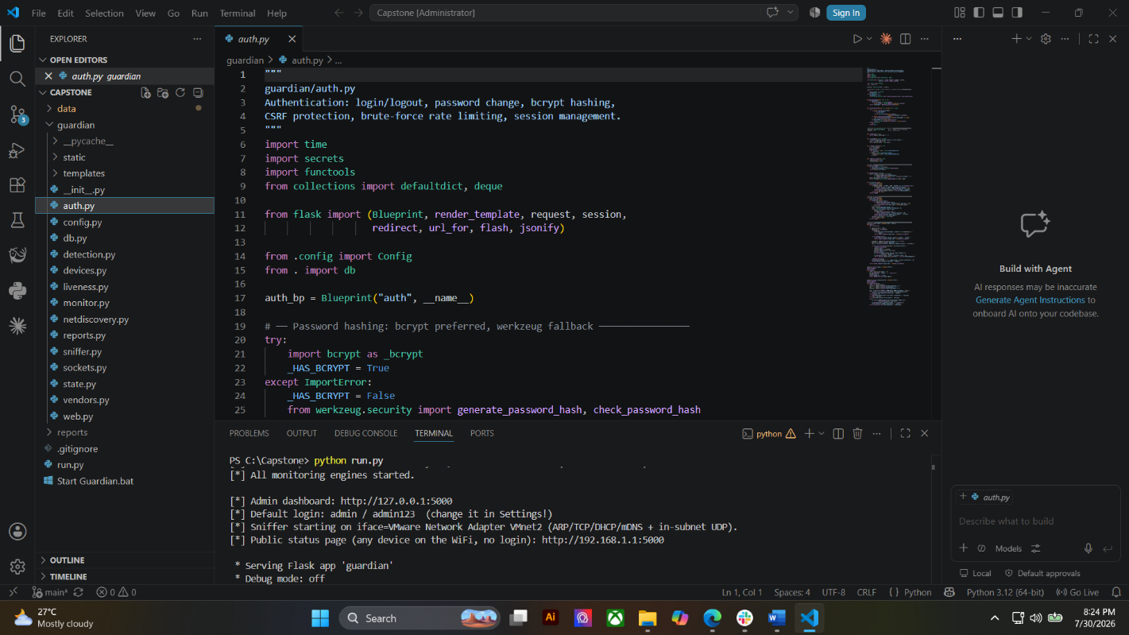

ACTIVITY 2
DATABASE IMPLEMENTATION

Purpose
To create the initial database structure required by the project.
Procedure
- Review the approved ERD.
- Create database schema.
- Create tables and relationships.
- Test database connectivity.
- Complete Form 2.

FORM 2
DATABASE IMPLEMENTATION REPORT

Directions
Document the database created for the project.
Project Database Name: guardian.db

Database Platform: SQLite 3 (file-based, WAL journal mode, synchronous = NORMAL)

Database Tables
Table Name | Purpose
admins | Stores administrator accounts and bcrypt password hashes; records last login time.
devices | Master registry of every device detected on the network: MAC, IP, hostname, vendor, online status, first/last seen, cumulative online time.
threats | All detected security threats with severity, source, evidence, detection rule, mitigation advice, workflow status and detection latency.
connection_log | Historical log of device connect / disconnect / reconnect events.
admin_log | Audit trail of administrator actions (login, logout, password change, settings change, report export).
reports | History of exported reports — type, format, filename and the user who generated it.
settings | Key-value store for runtime configuration (alarm toggle, probe interval, offline threshold).

Relationships Implemented
Relationship | Status
One-to-One | Not Applicable
One-to-Many | Implemented
Many-to-Many | Not Applicable
Required Evidence
□ ERD Diagram
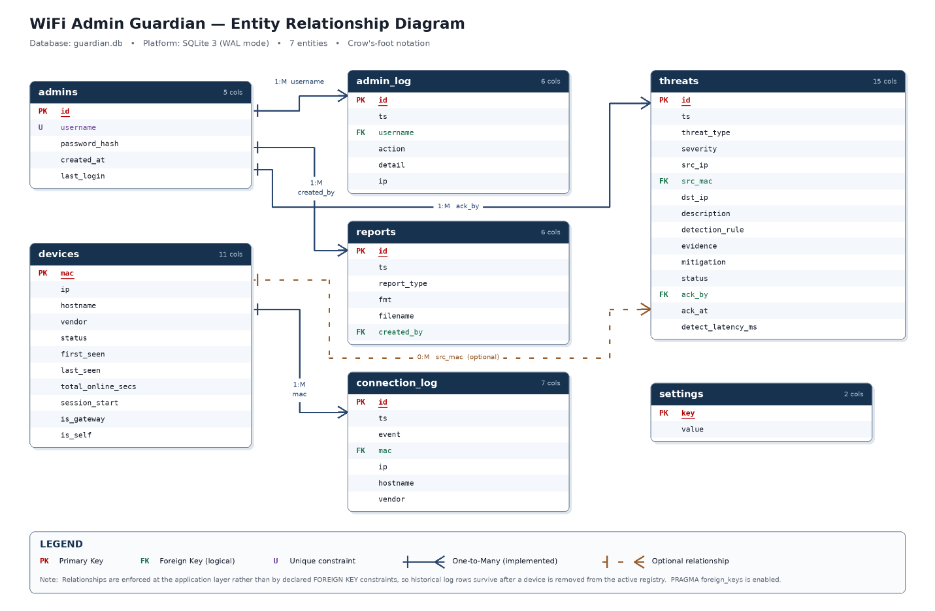

□ Database Screenshot
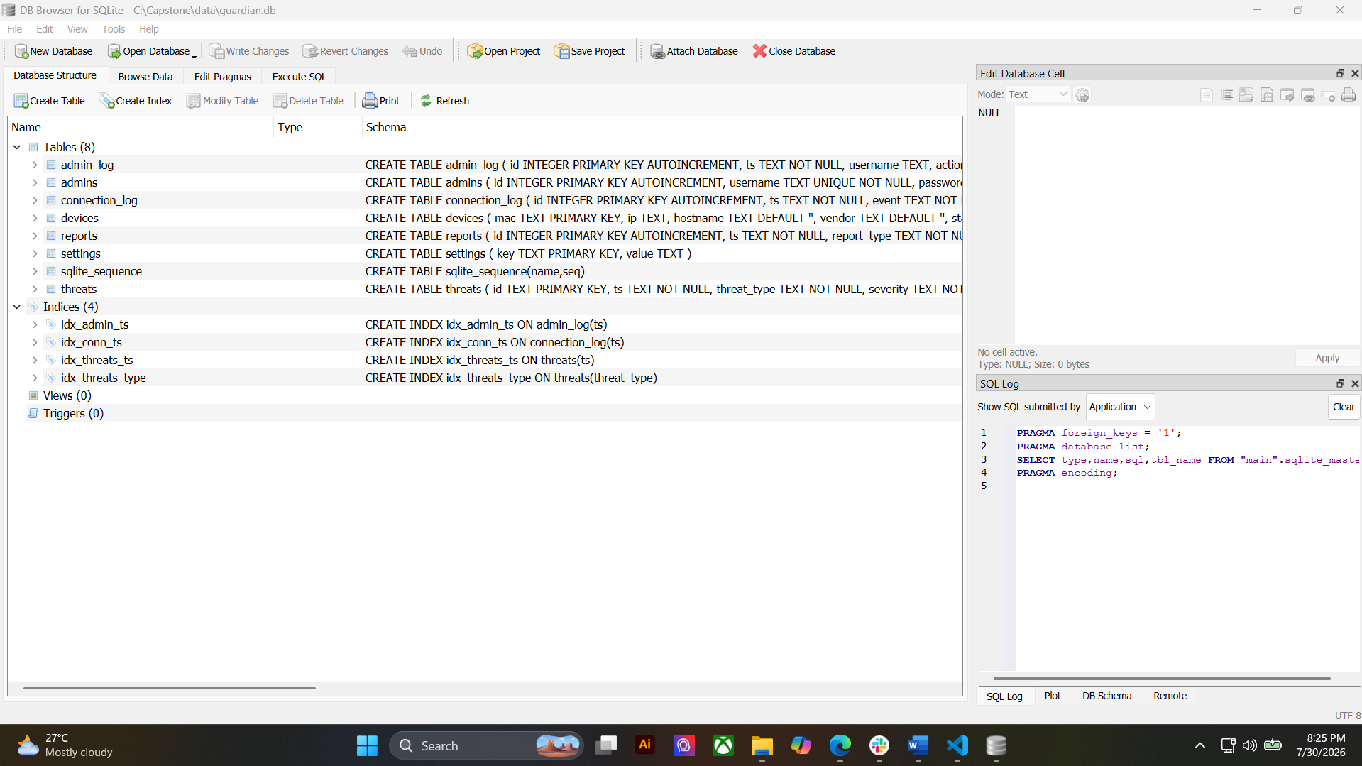

□ Table Structure Screenshot
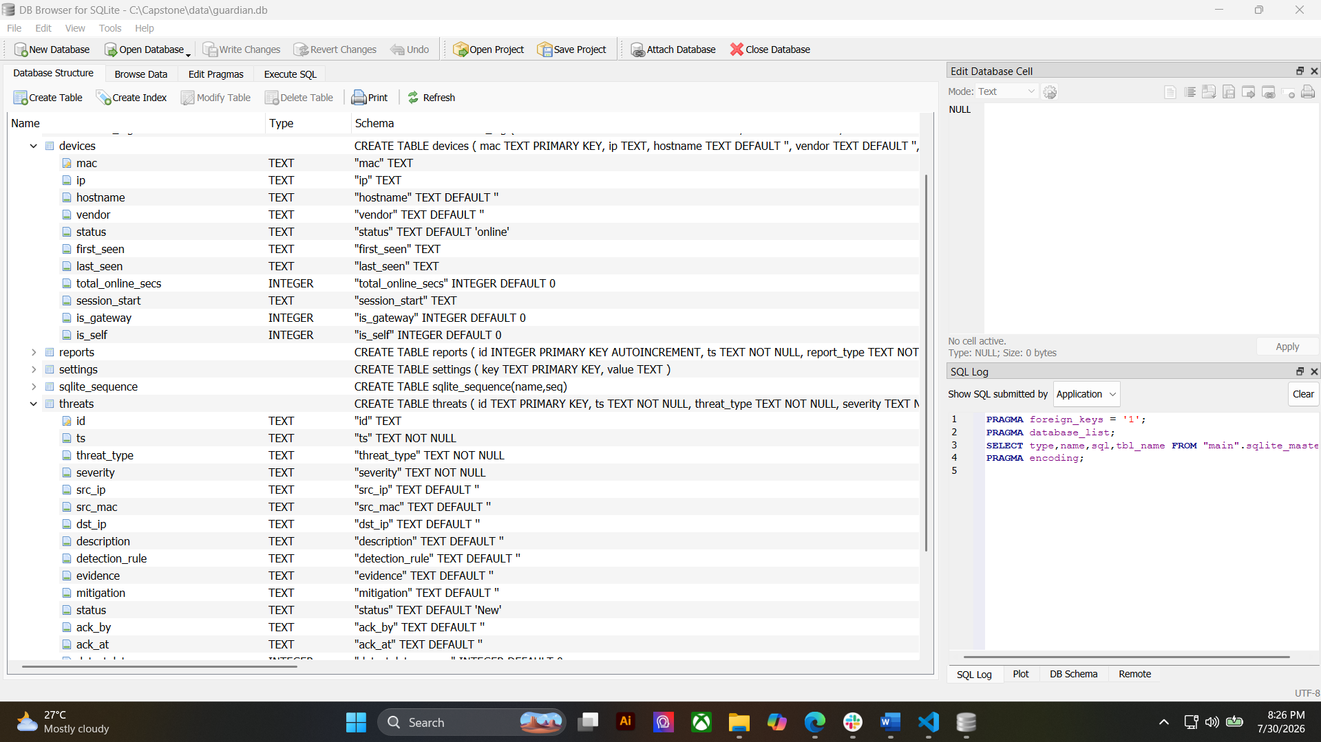

□ Connectivity Test Screenshot
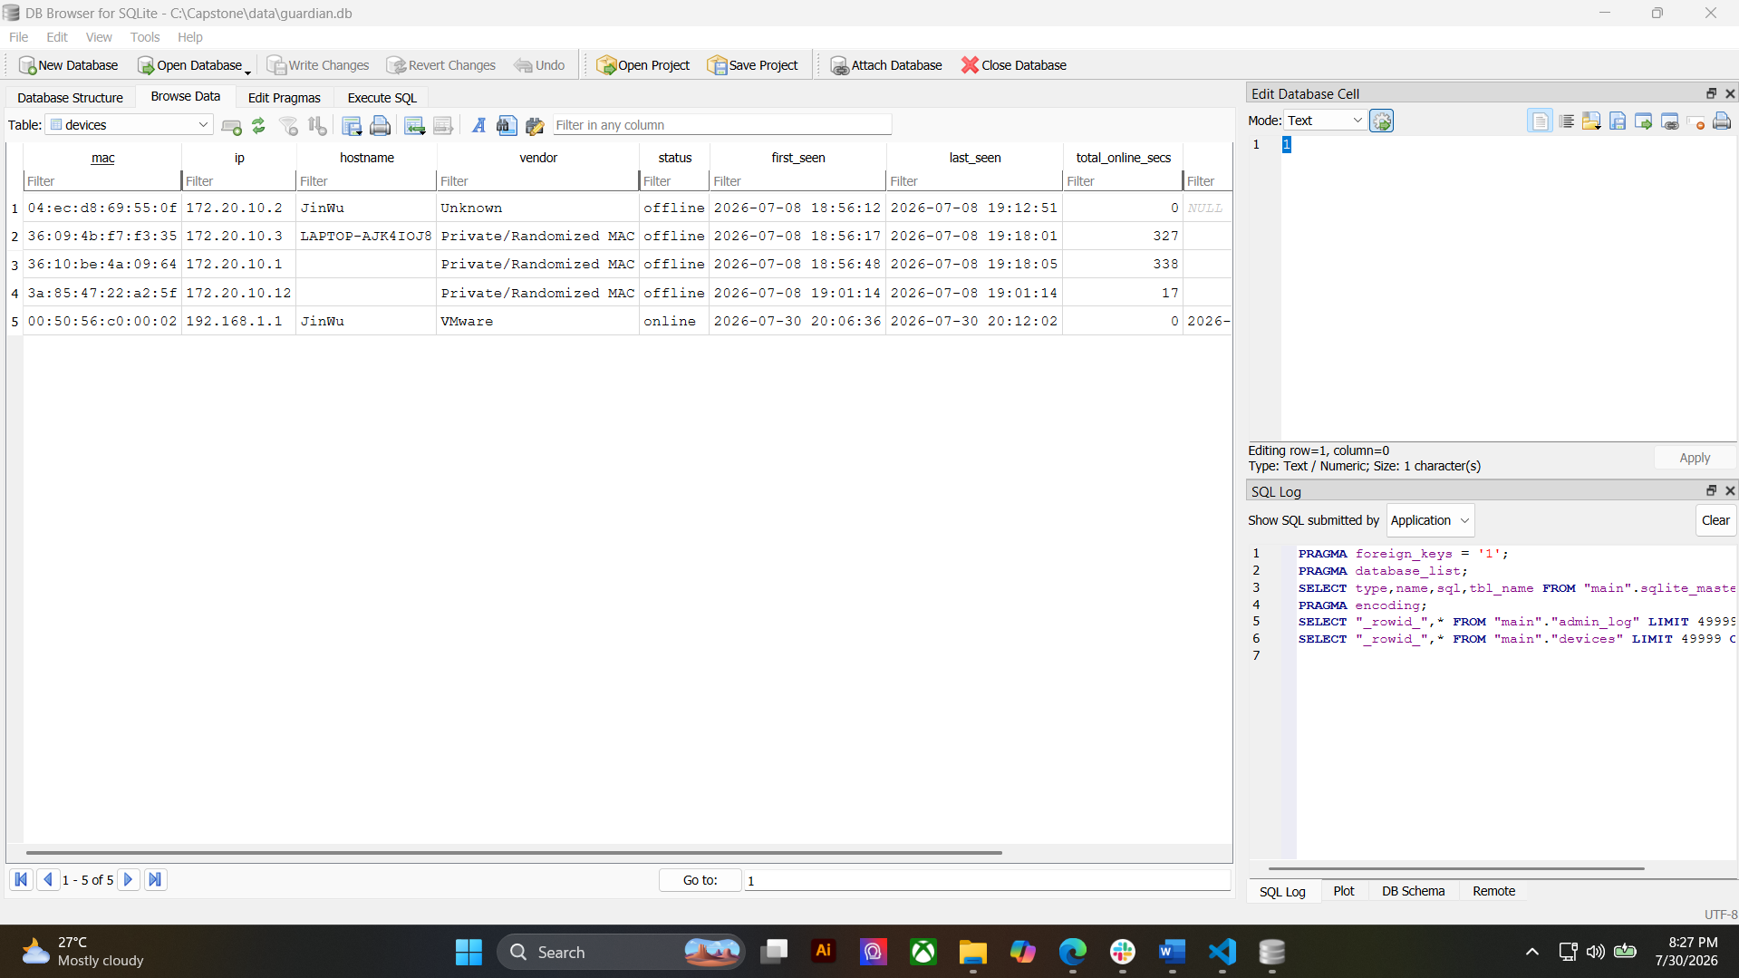

ACTIVITY 3
FRAMEWORK AND PROJECT STRUCTURE SETUP

Purpose
To establish a maintainable project structure for development.
Procedure
- Create application folders.
- Configure framework.
- Create initial configuration files.
- Verify successful project execution.
- Complete Form 3.

FORM 3
PROJECT STRUCTURE REPORT

Directions
Document the project architecture.
Folder | Purpose
frontend | The user interface — the web pages, styling, scripts and icons the dashboard uses.
backend | The application logic — handles login, network monitoring, threat detection, and reports.
database | Stores all the data — devices, threats, connection logs, and settings.
documentation | Project documentation — setup and usage guide, system architecture, database reference, and coding standards.
testing | Automated tests that check the threat detection, login security, and database all work correctly.

Framework Configuration
Framework: Flask (Python web framework) with Flask-SocketIO for real-time updates

Version: Flask 3.1.0 and Flask-SocketIO 5.6.0

Project Structure Validation
☑ Folder Structure Created
☑ Configuration Files Created
☑ Framework Running Successfully

ACTIVITY 4
FOUNDATIONAL MODULE DEVELOPMENT

Purpose
To create the basic modules that will serve as the foundation of the system.
Suggested Foundational Modules
- User Authentication
- Login Page
- User Registration
- Dashboard Layout
- Navigation Menu
- Database Connection Module
Procedure
- Develop at least one foundational module.
- Verify module functionality.
- Upload code to repository.
- Complete Form 4.

FORM 4
INITIAL MODULE DEVELOPMENT REPORT

Directions
Document all foundational modules completed.
Module | Description | Status
User Authentication | Login and logout with bcrypt password hashing (cost 12), session management with idle timeout, CSRF protection, and brute-force rate limiting. | Complete
Login Page | Branded sign-in interface with server-side validation and flash messaging. | Complete
Dashboard Layout | Administrator dashboard with summary cards, six tabbed panels and live charts. | Complete
Navigation Menu | Tab-based navigation across Overview, Devices, Threats, Logs, Reports and Settings. | Complete
Database Connection Module | Thread-safe SQLite layer with WAL mode, schema creation, serialized writes and automatic data retention. | Complete
Packet Capture Module | Continuous background sniffing of ARP, TCP, UDP, DHCP and mDNS traffic using Scapy with an optimized kernel-level filter. | Complete
Threat Detection Engine | Detects MITM, ARP poisoning, MAC spoofing, port scanning and rogue DHCP, with active confirmation to suppress false alarms. | Complete
Device Monitoring Module | Real-time device registry with connect / disconnect / reconnect detection in approximately 6 to 10 seconds. | Complete
Report Module | Generates Threat, Connection, Device and Security Summary reports in CSV and PDF format. | Complete
Public Status Page | Login-free network safety page accessible to any device on the Wi-Fi, showing a SAFE / CAUTION / THREATS DETECTED verdict. | Complete

Module Testing
Test Performed | Result
Login Function Test | Pass
Database Connection Test | Pass
Navigation Test | Pass

Required Evidence
□ Screenshots of Running Module
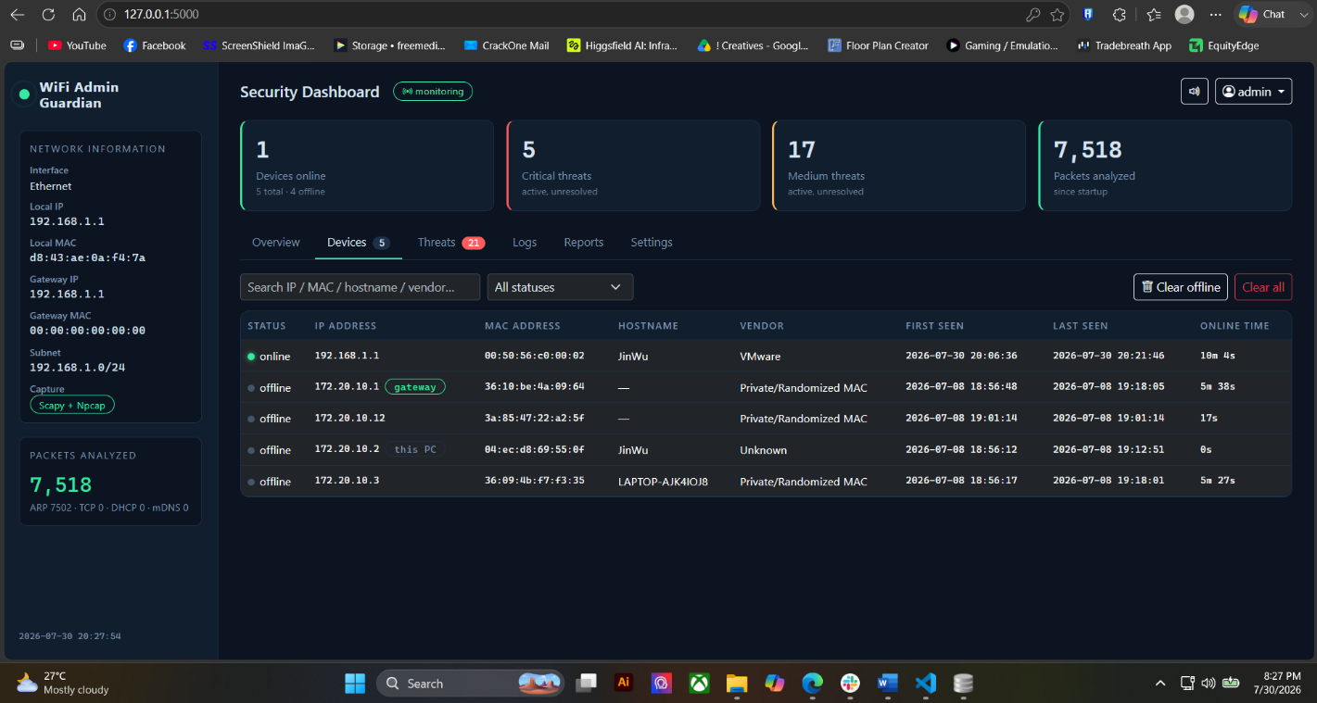

□ Source Code Screenshot
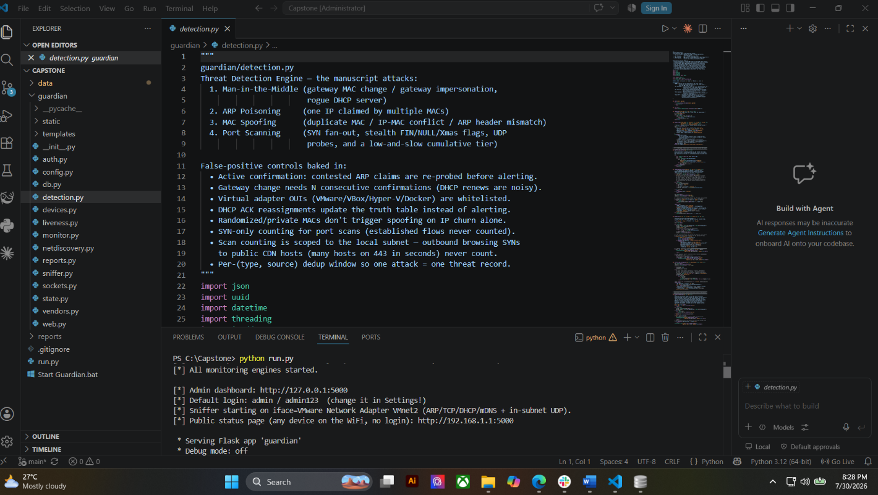

□ Demonstration Screenshot
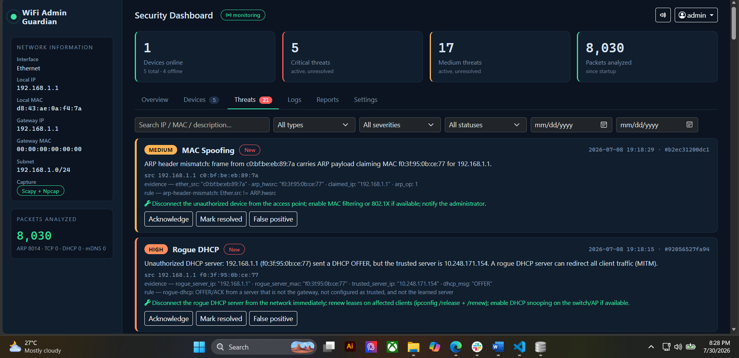

ACTIVITY 5
CODING STANDARDS ESTABLISHMENT

Purpose
To ensure consistency and maintainability of source code.
Procedure
- Agree on naming conventions.
- Define file organization standards.
- Define documentation standards.
- Define commit message standards.
- Complete Form 5.

FORM 5
CODING STANDARDS AGREEMENT

Naming Conventions
Item | Standard
Variables | lower_snake_case
Functions | lower_snake_case; a leading underscore marks internal helper
Classes | PascalCase
Tables | lowercase, singular words joined by underscore
Files | lowercase, one word, no separators

Documentation Standards
☑ Source Code Comments Required
☑ Function Documentation Required
☑ Database Documentation Required

Repository Standards
Commit Format: Imperative one-line summary (max ~72 characters), then a blank line, then a body explaining what changed and why.

Branching Strategy: main holds stable, working code. All development happens on descriptive feature branches, which are merged into main through Pull Requests after review.

Team Agreement
All members agree to follow the coding standards established above.
Member Signatures:
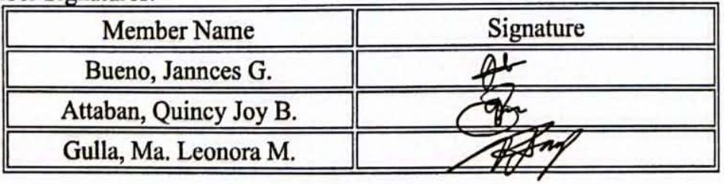

ACTIVITY 6
REPOSITORY INITIALIZATION

Purpose
To establish version control and collaboration mechanisms.
Procedure
- Create project repository.
- Upload project structure.
- Commit initial files.
- Add team members.
- Complete Form 6.

FORM 6
INITIAL SOURCE CODE REPOSITORY REPORT

Repository Name: Capstone2

Repository URL: https://github.com/jannces/Capstone2

Team Access
Member | Access Granted
Jannces G. Bueno – jannces (repository owner) | Yes
Quincy Joy B. Attaban – quincyjoyattaban-gif | Yes
Ma. Leonora M. Gulla – pawipiwie | Yes
Dr. Romero Dante C. Salum | No

Initial Commits
Commit Description | Date
Add files via upload — project source code and structure | July 30, 2026
Create readme.md | July 30, 2026
Add files via upload | July 30, 2026
Add files via upload | July 30, 2026

Required Evidence
□ Repository Homepage Screenshot
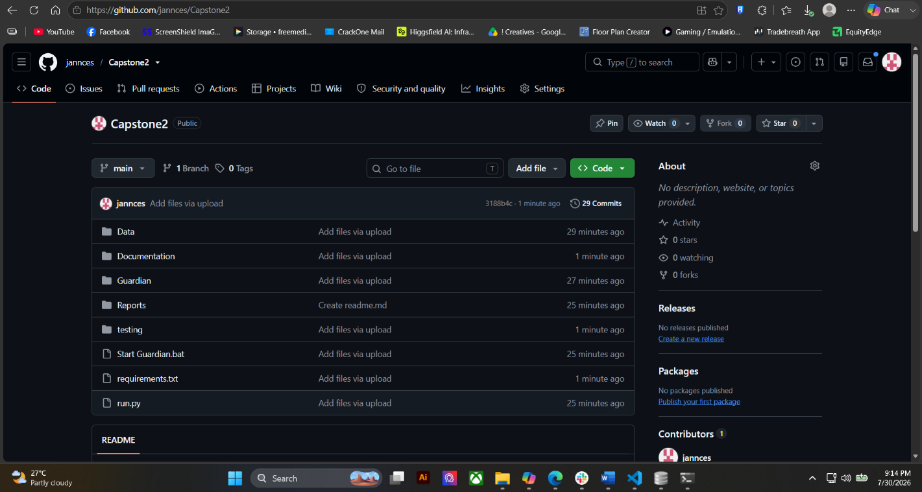

□ Initial Commit Screenshot
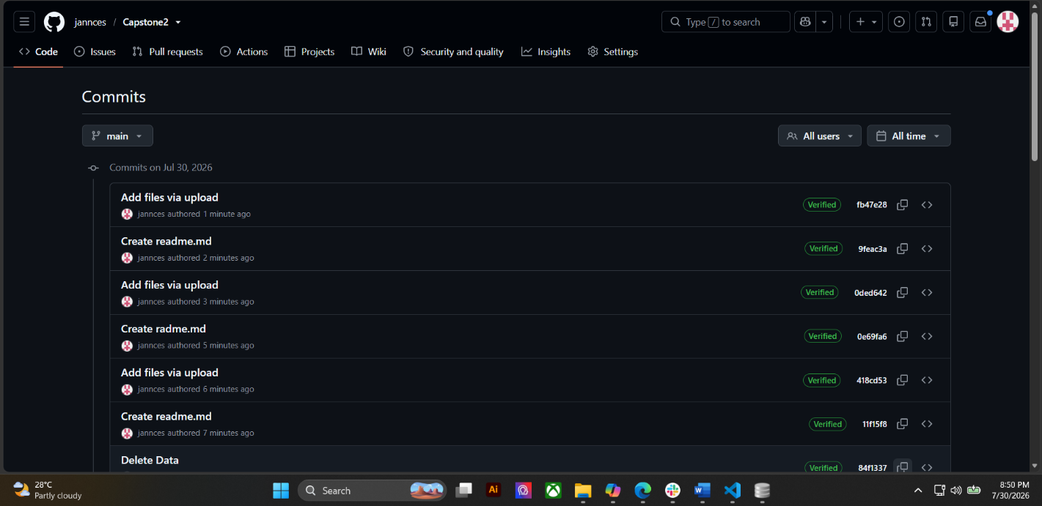

□ Project Structure Screenshot


□ Team Access Screenshot
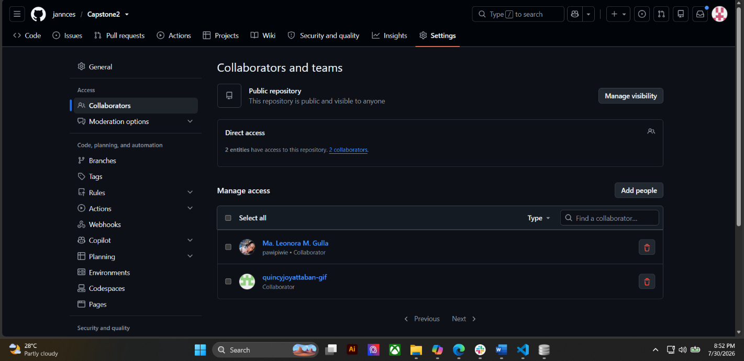

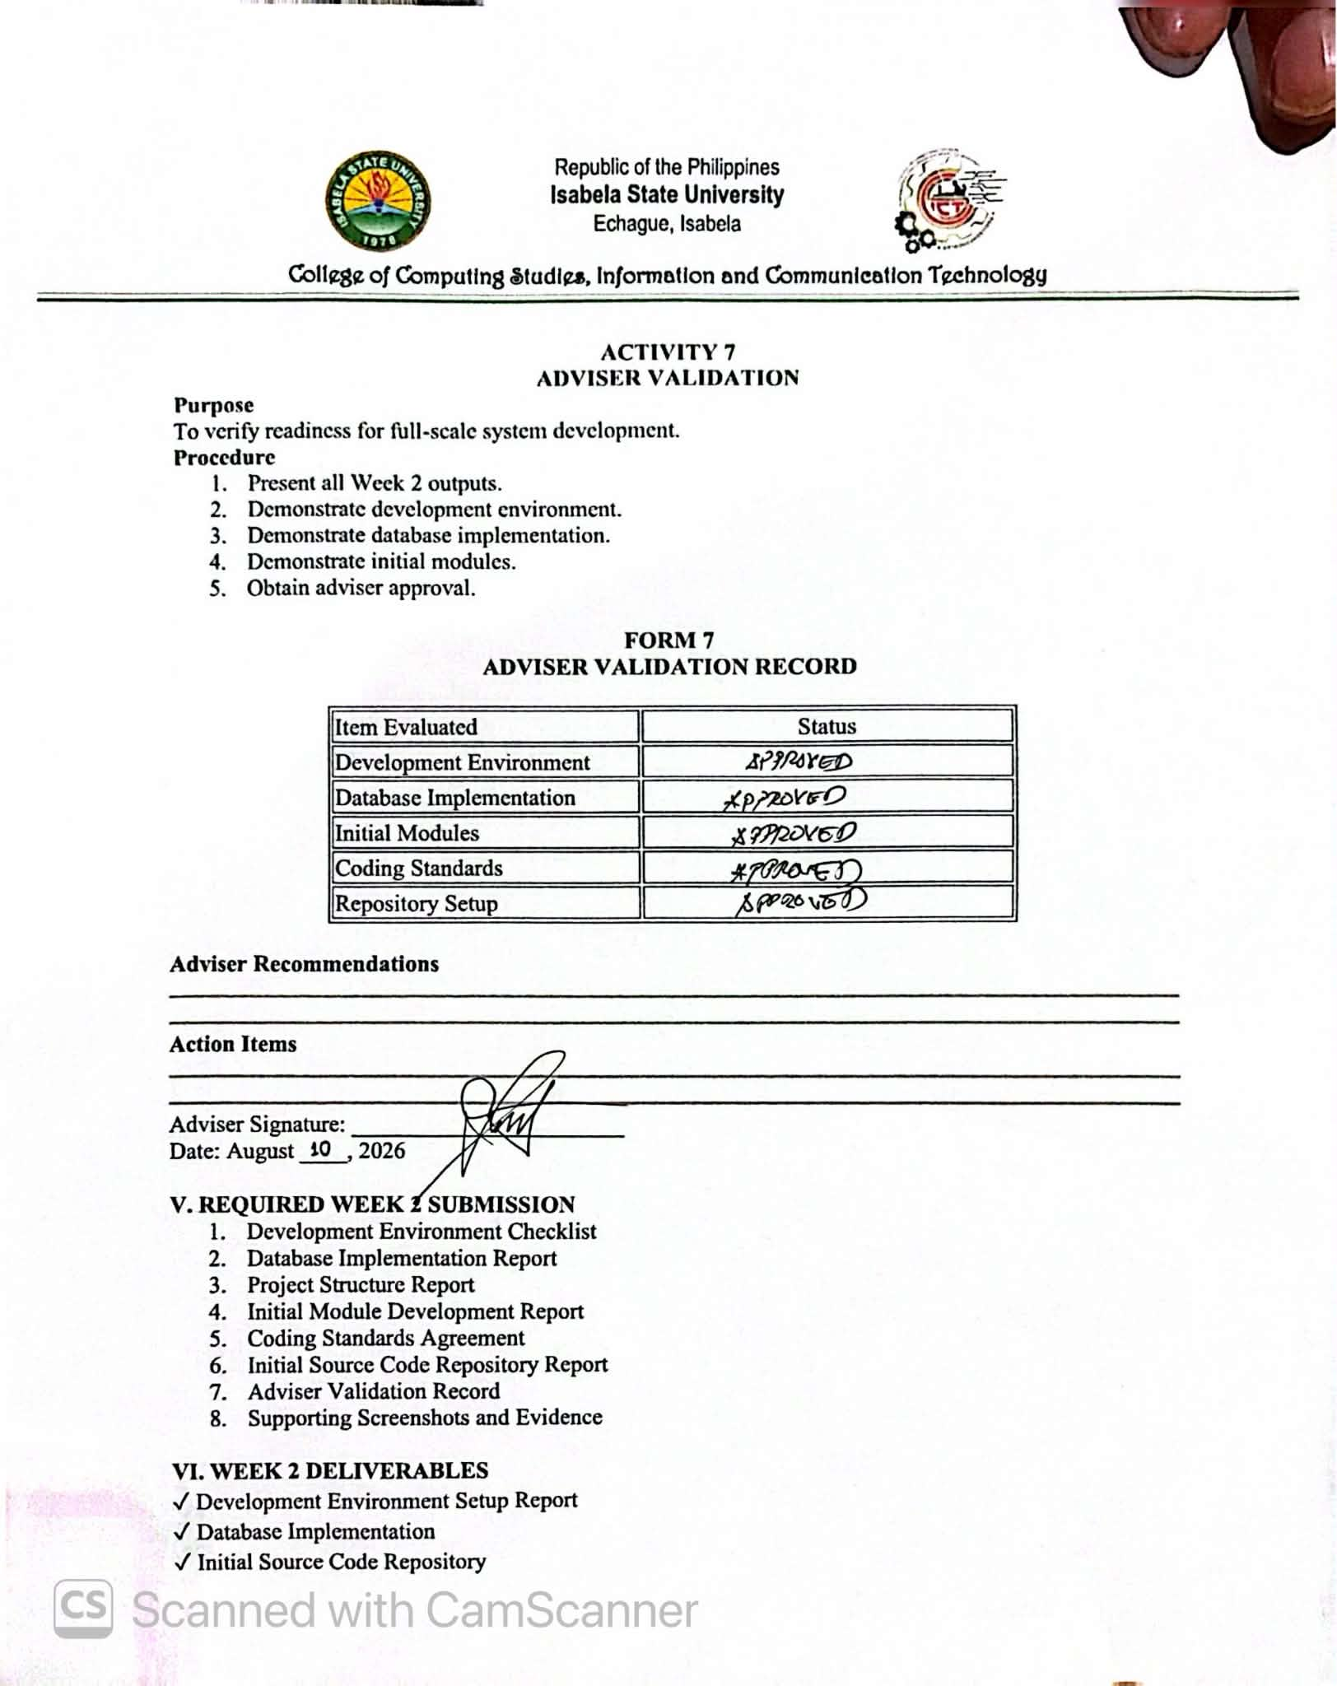

✓ Initial Functional Module
✓ Coding Standards Agreement

